Spatiotemporal Change Detection and Analysis in Remote Sensing Imagery

# Raunak Sarbajna, Dr. Sujing Wang

## Department of Computer Science, Lamar University

# Abstract

The purpose of this study is to detect spatiotemporal changes within sequential maps. Change analysis models are essential in understanding larger patterns and trends in multifaceted, time-series geographic data. All polygons under consideration are closed. spatial, georeferenced sets. The change detection is done through three primary set operations: union, intersection and erase. We calculate area of each individual polygon within each map layer. We then execute a union operation and calculate area. The union layer now contains the original areas of both layers and the areas of the overlapping polygons - we now need to query them properly to prepare for calculating the change percentage and tabulating intersection. To outline the polygon, we examine several different methods: (1) we find features common to either of the layers but not both, essentially performing a symmetrical difference, (2) we erase the larger of the polygons from the smaller, thus retaining only the growth, and do vice-verse for shrinking, (3) we perform simple intersection and then invert selection to get changed regions. All operations are performed using the ArcGIS/ArcPy toolkit. Our sample data for this process were shapefiles of drought intensity and impact from the North American Drought Portal.

# Introduction

Analyzing change in spatial data is critical for many applications including developing early warning systems that monitor environmental conditions, detecting political unrest and rime monitoring.

Change analysis models are essential in understanding larger patterns and trends in multifaceted, time-series geographic data. The purpose of this study is to detect spatiotemporal changes in land use within sequential (time-series) maps. Changes in land use can be categorized by the complex interaction of structural and behavioral factors associated with technological capacity, demand, and social relations that affect both environmental capacity and the demand, along with the nature of the environment of interest.

The goal of this research project is to detect and analyze how the patterns of features change over time and space in spatiotemporal land use datasets. All polygons under consideration are closed spatial georeferenced sets, rather than raster imagery.

Our approach provides a change monitoring framework which creates a change graph that captures the changes in spatial land uses clusters and a change summarization framework that creates specific change summaries based on the change graph based on the change story types.

# Literature Review

A survey of the classical change detection algorithms can be found in the Lu et al. [3] paper and tells us that the integrated GIS and remote sensing approaches yield the best results. However, they are very sensitive to registration accuracies between images. Thus, images must be properly orthorectified and georeferenced, especially because the changes in the emotion polygons are so subtle. This assumes the emotions are to be treated as just another feature in the map, like any other category.

Since our data is primarily in an urban environment, with all the grid like rigidity that entails, it is a good idea to look at change detection algorithms optimized for urban environments. One of the hardest aspects to measure is to distinguish between change and no-change, as well as different kinds of change. Comparing image differencing, image regression, tasseled-cap transformation and chi square transformation, Ridd and Liu [3] find image differencing to be the most consistent, with a sustained overall accuracy of > 80%.

It is useful to have a programming-oriented study comparing several of the change detection algorithms using MATLAB, rather than pure application-oriented comparison, in order to have a benchmark. Minu and Shetty [5] analyzed image differencing, image ratioing, change vector analysis, tasseled cap transformation and principal component analysis for efficiency and effectiveness. Although their area of study was not urban but a variety of land use/ land cover, change vector analysis gave the best overall accuracy.

We also studied two novel methods that are recent developments and are showing promising results: Neighborhood Correlation Image and Comprehensive Change Detection Method, both of which are optimized for remote sensing imagery but can be adapted to vectorized maps without loss of generality.

The change detection model using Neighborhood Correlation Image (NCI) logic works because of the obvious fact that the same geographic area (e.g., a 3x3 pixel window) on two dates of imagery will tend to be highly correlated if little change has occurred, and uncorrelated when change occurs [1]. Computing the piecewise correlation between two data sets demonstrates that NCIs contain change information and that NCIs may be powerful tools for change detection.

A high-performance remote sensing method called Comprehensive Change Detection Method (CCDM) integrates spectral-based change detection algorithms and a novel change model called Zone, which extracts change information from two Landsat image pairs [2]. This can be easily modified to work on the Twitter-based emotional grading maps. This method is simple, easy to operate, widely applicable, and capable of capturing anthropogenic changes like our area of interest.

# Methodology

Our initial approach to this problem was to store all shapefiles in a postgres database with a GIS addon and perform operations in python. We used psycopg2 and osgeo libraries to import, process and visualize maps. However, this lead to many problems with interconversions between georeferencing schemes, while converting from WKT geometry to PostGIS geography.

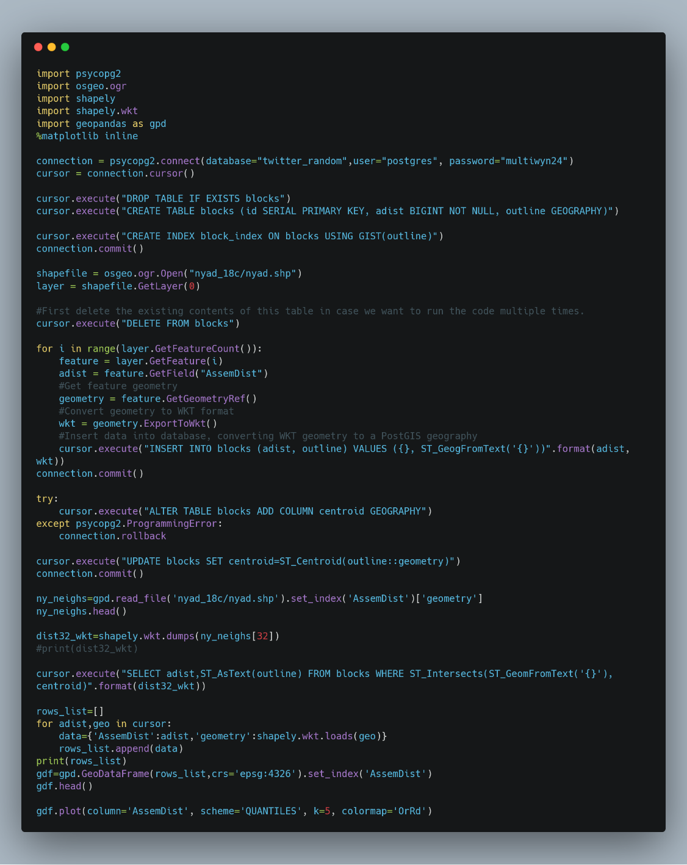

Figure Sample Python Code for processing shapefiles

Our next, more successful approach, was done through three primary set operations: union, intersection and erase. We calculate area of each individual polygon within each map layer. We then execute a union operation and calculate area. The union layer now contains the original areas of both layers and the areas of the overlapping polygons - we now need to query them properly to prepare for calculating the change percentage and tabulating intersection. To outline the polygon, we examine several different methods: (1) we find features common to either of the layers but not both, essentially performing a symmetrical difference, (2) we erase the larger of the polygons from the smaller, thus retaining only the growth, and do vice-verse for shrinking, (3) we perform simple intersection and then invert selection to get changed regions.

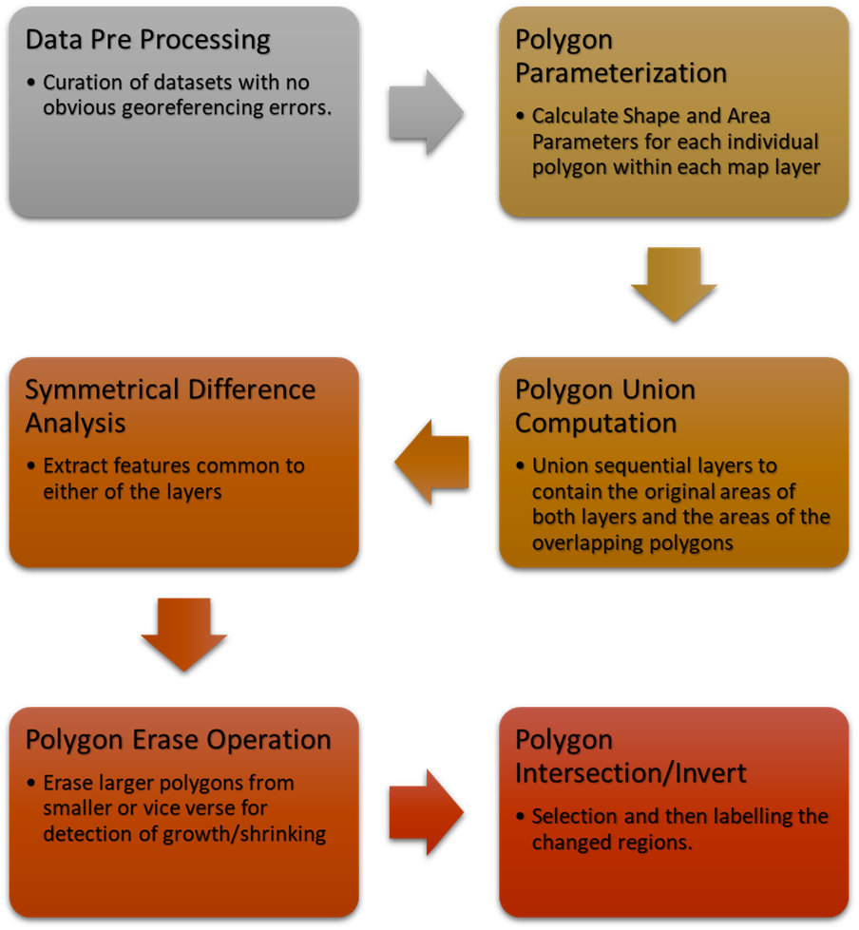

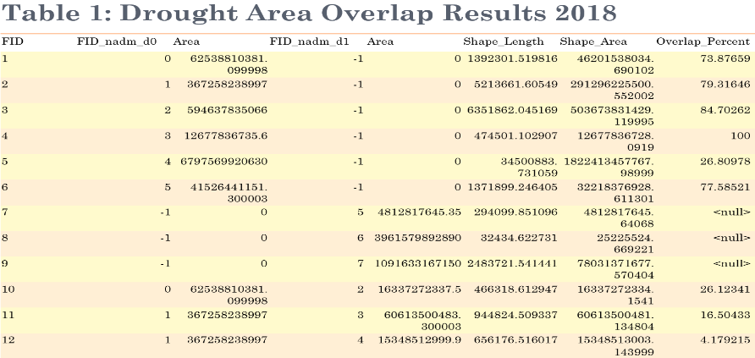Figure Map analysis methodology

Our change predicates include:

1. S-Continuing (c,m) $↔$ Agreement (c,m) ≥ 0.8
2. B-Continuing(c,b) $↔$ Oap (c,b) ≥ 0.8
3. Growing(c,m) $↔$ Contaiverlnment (c,m) ≥ 0.9
4. Shrinking(c,m) ↔ Growing (m,c)
5. Disappearing(c)↔ ∃i (belong-to(c,i)
6. Novel (c) ↔ ∃i (belong-to(c,i) and (i=1 or not(B-Continuing(c,i-1))

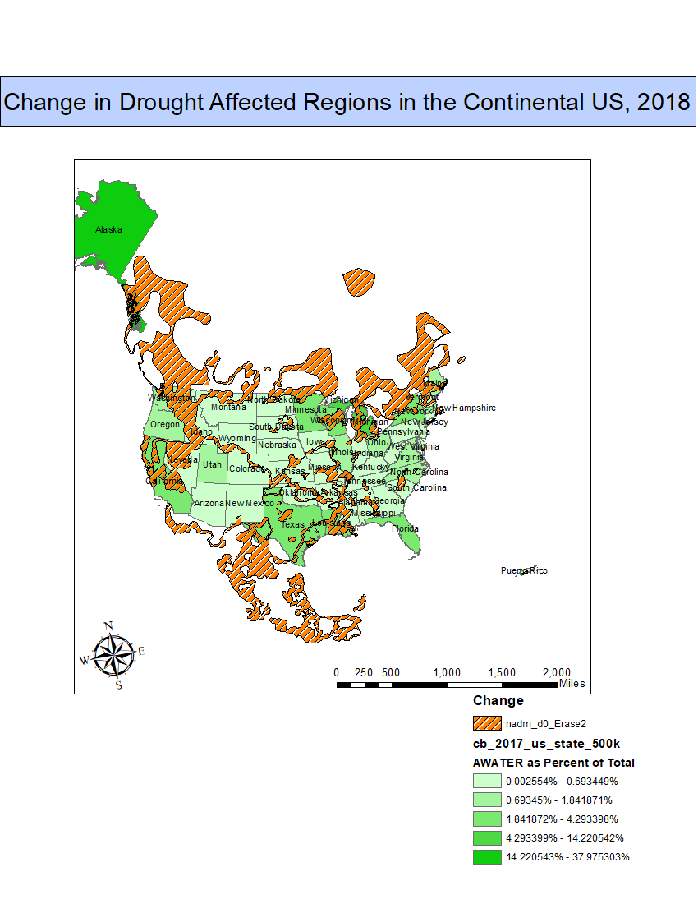

### References

1. J. Im and J. Jensen. 2005. A change detection model based on neighborhood correlation image analysis and decision tree classification. *Remote Sensing of Environment* 99, 3 (2005), 326–340. DOI:http://dx.doi.org/10.1016/j.rse.2005.09.008
2. Suming Jin, Limin Yang, Patrick Danielson, Collin Homer, Joyce Fry, and George Xian. 2013. A comprehensive change detection method for updating the National Land Cover Database to circa 2011. *Remote Sensing of Environment* 132 (May 2013), 159–175. DOI:http://dx.doi.org/10.1016/j.rse.2013.01.012
3. D. Lu, P. Mausel, E. Brondízio, and E. Moran. 2004. Change detection techniques. *International Journal of Remote Sensing* 25, 12 (June 2004), 2365–2401. DOI:http://dx.doi.org/10.1080/0143116031000139863
4. Merrill K. Ridd and Jiajun Liu. 1998. A Comparison of Four Algorithms for Change Detection in an Urban Environment. *Remote Sensing of Environment* 63, 2 (1998), 95–100. DOI:http://dx.doi.org/10.1016/s0034-4257(97)00112-0
5. S. Minu and Amba Shetty. 2015. A Comparative Study of Image Change Detection Algorithms in MATLAB. *Aquatic Procedia* 4 (March 2015), 1366–1373. DOI:http://dx.doi.org/10.1016/j.aqpro.2015.02.177